**SCOTT SCHMIDT 8/22/21**

**SQL Assessment Test 2**

**Questions and Expected Results**

Keep in mind there is usually more than one way to answer these questions.

These questions start off with the basics and then get continually more difficult.

1. How can you retrieve all the information from the cd.facilities table?
   * **Expected Result should look similar to this (with more rows):**

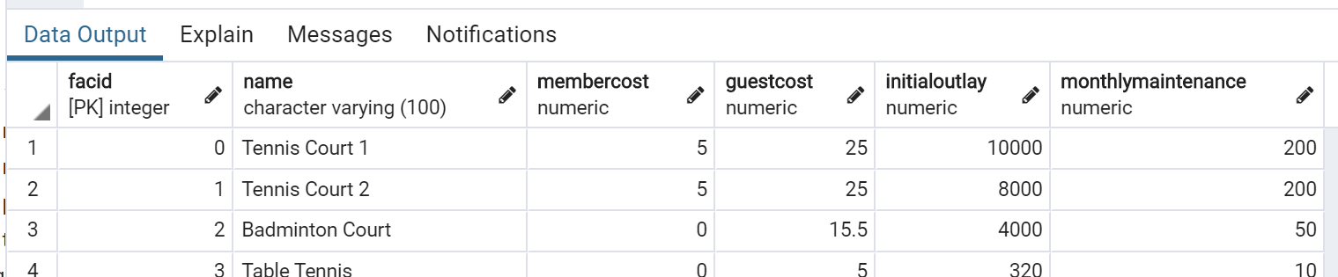

**Select * from cd.facilities**

1. You want to print out a list of all of the facilities and their cost to members. How would you retrieve a list of only facility names and costs?

**Select name, membercost from cd.facilities** 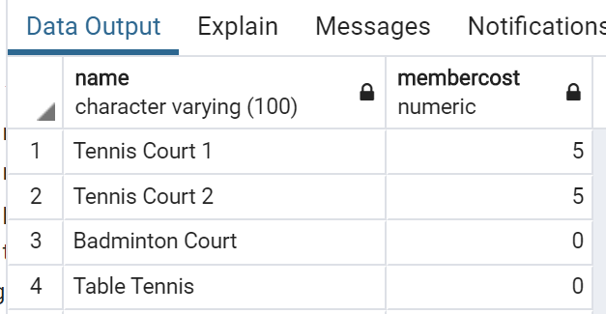

1. How can you produce a list of facilities that charge a fee to members?
   * Expected Results should have just 5 rows:

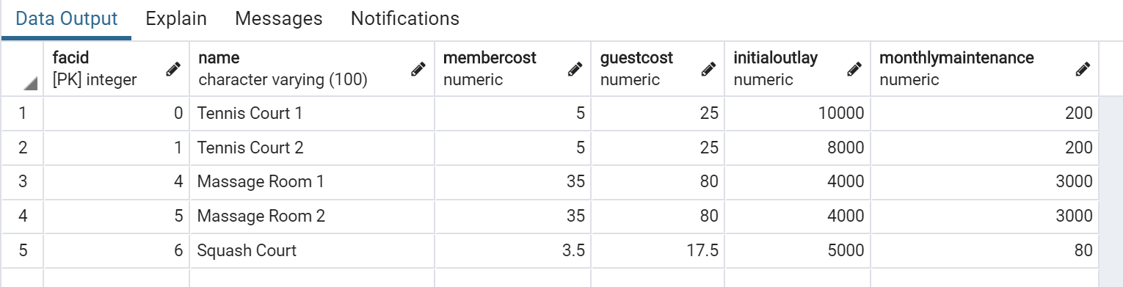

**Select name, facilities from cd.facilities where membercost>0**

1. How can you produce a list of facilities that charge a fee to members, and that fee is less than 1/50th of the monthly maintenance cost? Return the facid, facility name, member cost, and monthly maintenance of the facilities in question.
   * Result is just two rows:

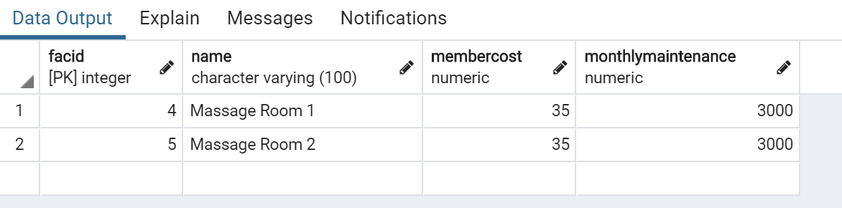

**Select name, facilities from cd.facilities where membercost>0 AND (monthlymaintenance/50) < fee**

1. How can you produce a list of all facilities with the word 'Tennis' in their name?
   * **Expected Result is 3 rows**
   * 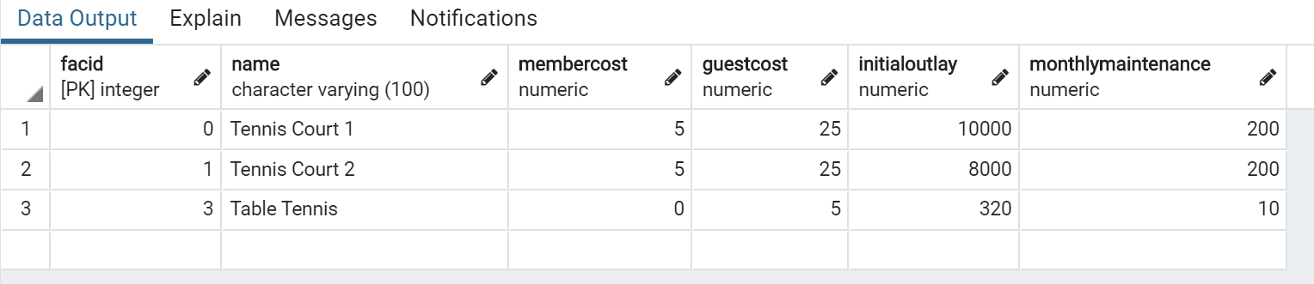

**Select * from cd.facilities where LIKE ‘%Tennis%’ in name**

1. How can you retrieve the details of facilities with ID 1 and 5? Try to do it without using the OR operator.

**Select * from cd.facilities where facid == 1 OR facid==5**

**Select * from cd.facilities where facid IN (1,5)**

* + **Expected Result is 2 rows**
  + 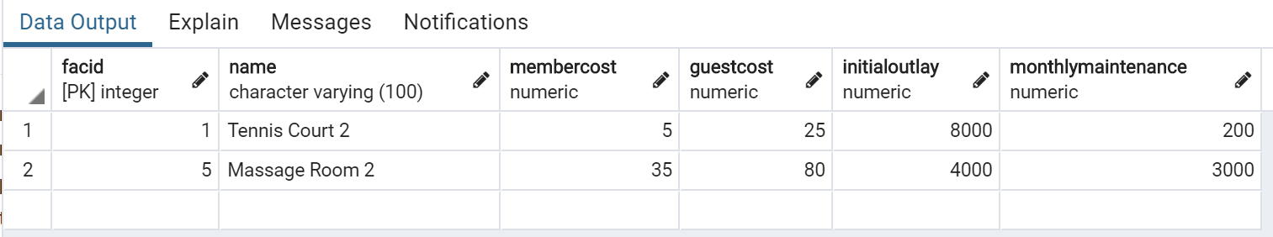

1. How can you produce a list of members who joined after the start of September 2012? Return the memid, surname, firstname, and joindate of the members in question.

**Select memid, surname, firstname, joindate where joindate > ‘2012-09-01’**

* + **Expected Result is 10 rows (not all are shown below)**
  + 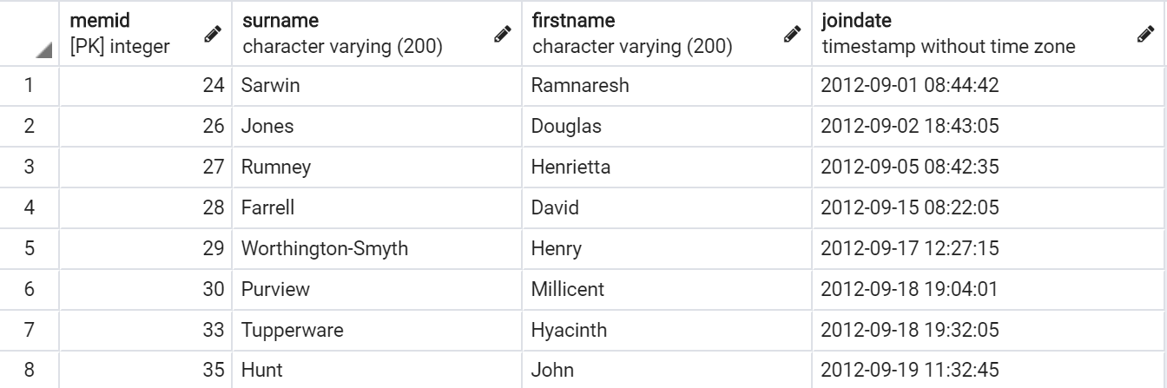

1. How can you produce an ordered list of the first 10 surnames in the members table? The list must not contain duplicates.

**SELECT DINSTINCT surname, firstname, joindate from cd.facilities GROUPBY surnames LIMIT 10**

* + **Expected Result should be 10 rows if you include GUEST as a last name**
  + 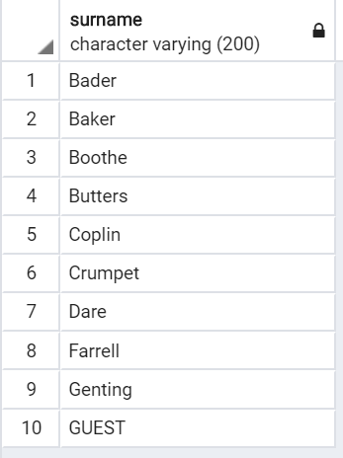

1. You'd like to get the signup date of your last member. How can you retrieve this information?

**SELECT min(joindate) from cd.facilities**

* + **Expected Result**
  + **2012-09-26 18:08:45**

1. Produce a count of the number of facilities that have a cost to guests of 10 or more.

**Select COUNT from cd.facilities where cost>=10**

* + **Expected Result**
  + **6**

1. Produce a list of the total number of slots booked per facility in the month of September 2012. Produce an output table consisting of facility id and slots, sorted by the number of slots.

**Select facid, SUM(slots) as total_slots from cd.bookings WHERE starttime >= ‘2012-09-01’ AND starttime =< ‘2012-10-01’ GROUP BY facid ORDER BY SUM (slots)**

* + **Expected Result is 9 rows**
  + 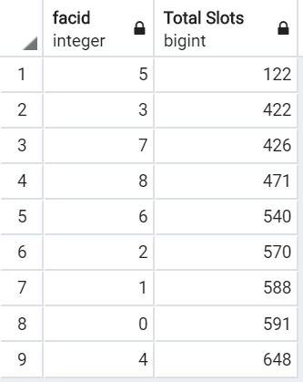

1. Produce a list of facilities with more than 1000 slots booked. Produce an output table consisting of facility id and total slots, sorted by facility id.

**SELECT facid_id, sum(slots) as total_slots**

**FROM cd.bookings**

**HAVING sum(slots) > 1000**

**ORDER BY facility_id**

* + **Expected Result is 5 rows**
  + 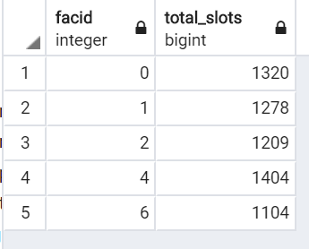

1. How can you produce a list of the start times for bookings for tennis courts, for the date '2012-09-21'? Return a list of start time and facility name pairings, ordered by the time.

**SELECT cd.bookings, starttime, cd.facilities.name**

**FROM cd.facilities**

**INNER JOIN cd.bookings**

**ON cd.facilities.facidid = cd.bookings.faci**

**WHERE name = ‘%tennis%’**

**AND cd.bookings.starttime= ‘2012-09-21’**

**ORDER BY starttime**

* + **Expected Result is 12 rows**
  + 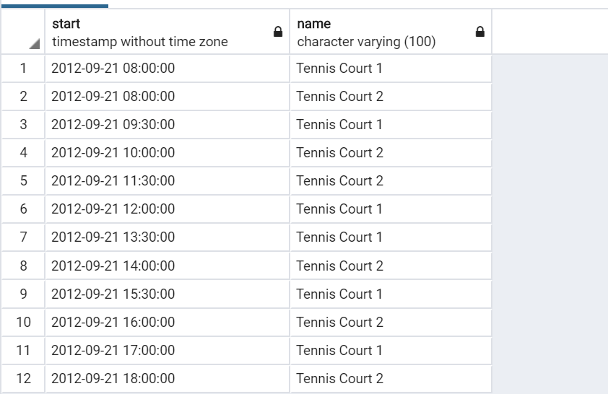

1. How can you produce a list of the start times for bookings by members named 'David Farrell'?

**SELECT cd.bookings.starttime**

**FROM cd.bookings**

**INNER JOIN cd.members ON**

**Cd.members.memid = cd.bookings.memid**

**WHERE cd.members.firstname = ‘David’**

**AND cd.members.surname = ‘Farrell’**

**result is 34 rows of timestamps**

For the solutions you can visit this link:

<https://docs.google.com/document/d/1swGZ0RG3KKqWqzmsI_qrMgjJ3lt39mtAJqRSMZy6Z-8/edit?usp=sharing>